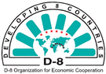
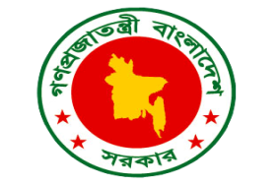
Logistics and Administrative Note
44th Session of the D-8 Commission

08-09 November 2021
Dhaka, Bangladesh

INTRODUCTION

The Government of the People’s Republic of Bangladesh is honored to welcome participants to the “44th Session of the D-8 Commission” to be held on 08-09 November 2021 in Dhaka, Bangladesh.

This Logistic and Administrative Note provides logistical and practical information on the details of the 44th Session of the D-8 Commission to be hosted by the Ministry of Foreign Affairs of the Government of the People’s Republic of Bangladesh.

Any amendments to this document will be communicated to all delegates via email.

Date and Venue:

Date: 08-09 November 2021

Venue: Hotel Intercontinental

Address: 1 Minto Road, GPO Box 504: Dhaka, 1000, Bangladesh

Phone: +880-2-55663030

Website: www.ihg.com/intercontinental/hotels/us/en/dhaka/dachb/hoteldetail

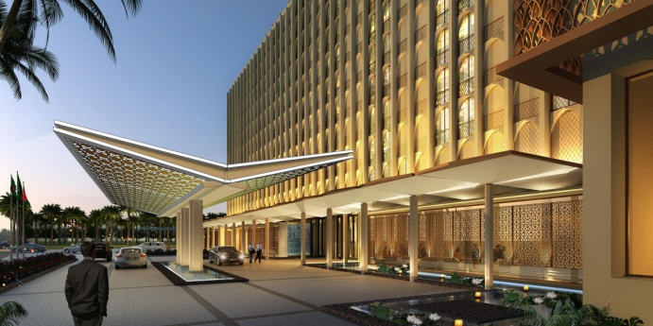
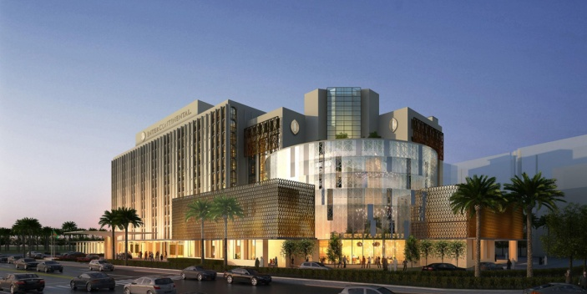

BEFORE THE MEETING

- Registration

Please confirm your participation no later than 20 October 2021 through the Registration Form sent to you.

- Visa Requirements

Prior visa is required to enter Bangladesh. Although, the Government of the People’s Republic of Bangladesh issues Visa on Arrival (VOA) for citizens of some countries, due to Covid-19 pandemic, all are requested to take prior visa from Bangladesh Embassies in their respective countries. The visa application must be submitted selecting the Bangladesh Embassy/High Commission in the country where the applicant is located. All participants are requested to send their necessary information with copy of passport, flight confirmation and hotel booking confirmation to (a) io1@mofa.gov.bd (b) io2@mofa.gov.bd (c) iowing@mofa.gov.bd by 20 October 2021. All participants and delegates must hold a valid passport preferably with 06 months validity or proper travel document. International Media personnel/journalists need prior visa to visit Bangladesh.

- Covid-19 Requirement

To avoid mandatory quarantine - upon arrival - during the pandemic situation, all participants are requested to fill out the Registration Form (attached) in details. The delegates need to submit a negative PCR test result taken within the 72 hours before their arrival to Dhaka. All participants should be vaccinated and must produce RT-PCR based Covid-19 negative certificate before the airport authority.

A letter with the details of the delegates will be issued by the Ministry of Foreign Affairs, Dhaka which needs to be produced to the Immigration Officer on arrival. The Ministry of Foreign Affairs, Dhaka will arrange Covid-19 test facilities at designated area of the Hotel Intercontinental. The delegates are requested to inform beforehand the date on which they want to have the test. Fee of Covid-19 test amounting 1500.00 Bangladeshi Taka (local currency) should be borne by each delegate.

- Hospitality and Accommodation

The accommodation of the Esteemed Head of Delegation + 1 official from 7-9 November 2021 for each Member State will be covered by Ministry of Foreign Affairs of the Govt. of the People’s Republic of Bangladesh at Hotel Intercontinental.

- Airport Transfer

Coaster cars, Micro Buses will be provided for the delegates from Hazrat Shahjalal International Airport to the Hotel Intercontinental Dhaka. There will be information desks at Hazrat Shahjalal International Airport, Dhaka and the Hotel Intercontinental for providing guidance on availing logistic support. In order to organize this service smoothly, delegates are requested to fill in the Registration Form indicating their arrival, departure and accommodation details and send it to (a) io1@mofa.gov.bd (b) io2@mofa.gov.bd (c) iowing@mofa.gov.bd latest by 20 October 2021.

- Meeting Agenda

The Draft Agenda of the Meeting has been sent to the Member States through the Secretariat.

- Badges

Please fill out the sign-in sheet and pick up your badge at the Information Desk 15 minutes prior to the Meeting. The identification badges should be worn by all participants throughout the meeting. You will be guided by staff at the information desk to the Meeting Room.

- Working Language(s)

The Meeting will be conducted in English.

OTHER USEFUL INFORMATION

- Currency, Banking, Credit Cards and ATMs

The official currency in Bangladesh is the Bangladeshi Taka. Foreign currency can usually be exchanged without commission at exchange offices, banks and hotels. Exchange rates are published daily in Bangladeshi newspapers and can also be found in the web site of Bangladesh Central Bank at: https://www.bb.org.bd/econdata/exchangerate.php

Major credit cards, such as Amex, Visa and MasterCard are accepted at hotels, restaurants, shops, etc. However, some restaurants and small shops accept only cash, so it is recommended to have some cash in Bangladeshi Taka with you.

Cash machines (ATMs) are available throughout Bangladesh, accepting major credit and bank cards and instructions are available in English.

- Climate

The average temperature in Dhaka in November is around 29 degree Celsius during daytime and 24 degree Celsius during night.

- Electricity

In Bangladesh the power plugs and sockets are of type C, D, G and K. The standard voltage is 220 V and the standard frequency is 50 Hz.

- Time Zone

Bangladesh Standard Time is six hours ahead of Greenwich Mean Time (GMT+6). Same time zone is used all over the country throughout the year.

- International Dialing Codes

The country code for Bangladesh +880. To make an international phone call, dial 00 + country code + phone number.

- Emergency Calls

999 is the national emergency number in Bangladesh.

All participants will be responsible for payment of any medical, surgical, dental, hospital or ambulance services that they require in Bangladesh and are advised to make appropriate arrangements for insurance. One ambulance will be ready for emergencies for 24 hours during the meeting at the hotel.

- Mobile Phone Services

There are 5 GSM operators in Bangladesh being as Teletalk, Grameenphone, Robi, Banglalink, Airtel. Please contact with the Information desk located at Hotel Intercontinental if you want to have any mobile SIM card.

- Business Hours

Type | Business Hours
Banks | 10.00-16.00 Sunday- Thursday
Museums | 09:30-16:30 Saturday- Wednesday, 15.30- 19.30 Friday
Shops | 09.00- 20.30

- Tax

Standard VAT Rate in Bangladesh is 15%.

- Smoking

Smoking is not permitted in public places including meeting facilities, taxis, cars in Bangladesh.

- Tipping
Tipping is not standard practice in Bangladesh but is generally considered an appropriate gesture of appreciation when the level of service has exceeded expectations in hotels and restaurants.

- Customs Regulations

For more information regarding customs regulations and restricted items please visit the following website: http://www.dip.gov.bd/, http://customs.gov.bd/index.jsf

- Diplomatic Missions in Bangladesh

The contact information of diplomatic missions in Bangladesh can be accessed on: https://mofa.gov.bd/site/page/3537a4d7-2b2f-4427-b8fa-a1ea81117dc3
https://mofa.gov.bd/site/page/63eee5d7-1d17-4088-9bad-a9a5b53b8bb8

- Sightseeing

Brochures including information about historical and touristic areas, sightseeing and other relevant information can be accessed via-http://www.tourismboard.gov.bd/

- Travelling to Bangladesh

Air Line Connections

Dhaka is well connected with other major cities of the world by air. Major airlines of the world are operating their flights to and from Dhaka. For more information, the following links may be visited:

https://www.biman-airlines.com/
https://www.emirates.com
https://www.saudia.com
https://www.qatarairways.com
https://www.singaporeair.com
https://US-Banglaairlines.com/
https://www.flynovoair.com/
https://www.flyregent.com/
- Safety and Security

The Government of Bangladesh will ensure the safety and security of all distinguished participants and delegates. Throughout the period of the Conference, special security measures will be taken at the Airport for the arrival and departure of VIP guests. Necessary security measures will be taken at all times at the Conference venue, the designated hotel and other function venues. Access to the Conference area will be restricted strictly to those displaying their respective accreditation badges.

Contact Information
Mr. Md. Ziaur Rahman
Email: io2@mofa.gov.bd
Mobile: +880-1719 577 194
Tel: +88029556712
Fax: +88029555283

