In the Name of God

The Final Report
of the

Second Meeting of
Directors General of Civil Aviation Authorities

ISFAHAN- ISLAMIC REPUBLIC OF IRAN
8- 10 SEP 2007

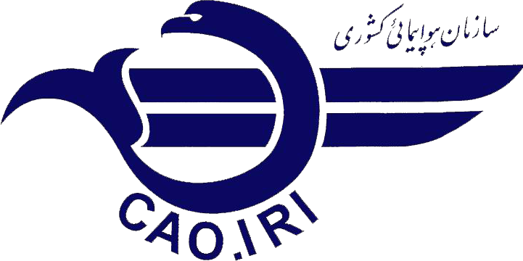
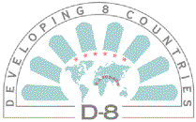

In the Name of God

The Final Report of the Second Meeting of Directors General of Civil Aviation Authorities

ISFAHAN- ISLAMIC REPUBLIC OF IRAN
8- 10 SEP 2007

The Vice Minister and President of Civil Aviation Organization of the I.R of Iran hosted the second meeting of D-8 Directors General of Civil Aviation in Isfahan on 08-10 Sep 2007. The esteemed delegates from the Republic of Turkey, the Republic of Indonesia, Malaysia, the Islamic Republic of Pakistan and Federal Republic of Nigeria attend the meeting, as depicted in Annex 1 under the list of participants.
The meeting was chaired by Capt. Khanlari, the Vice Minister of Road and Transportation and President of Civil Aviation Organization of the Islamic Republic of Iran. In his welcome speech, Capt. Khanlari requested the esteemed delegates to have close cooperation and great effort to achieve a common dialogue in the field of safety and security and reemphasized the implementation of the first DGCA Meeting outcomes.
The Secretary General, Mr. Dipo Alam, in his speech briefed the esteemed participants on the history and background of the D-8, elaborated the required facilitation on tourism and international trade, and reviewed the results of the last meeting on security and sought the assistance of the participants to work closely and finalize the draft of MOU for the signature of the members.
The distinguished delegates of Pakistan, Malaysia and Nigeria made audio-visual presentations on their own civil aviation organization activities and their latest progress in different scopes of air industry.
Based on the program of the meeting, the distinguished delegates had an official half a day visit from the HESA Civil Aircraft Manufacturing Company.
The draft of MOU For The Establishment Of D- 8 Member States' Working Group For Co-Operation In Civil Aviation prepared in the last meeting in Antalya, 27-29 Jun 2007 was put on the table for final

reviewing by distinguished delegates and making any last necessary amendments. In the last session of the meeting, the final draft of MOU was signed by Secretary General of D-8 secretariat and the attending DGCA of the Republic of Turkey, the Republic of Indonesia and President of Civil Aviation Organization of the Islamic Republic of Iran. The MOU was left open for the signature of the other Members The Republic of Turkey was appointed to be the Chairman of the D-8 Working Group for two years. It was decided that the third session of the D-8 working group to be held in Istanbul.
At the end of the meeting the capabilities of the member States in the air industry was reminded to distinguished delegates by the Secretary General and insisted that the relevant data should be exchanged between the States in order to take necessary measures on the needs of each party. Each delegates, in turn, expressed their gratitude to the president of Civil Aviation Organization of Islamic Republic of Iran for the kind hospitality and considerable arrangements made for the meeting.

